# Graphics Coursework CSC8502

## To control camera:

WASD to control the camera. Use shift to move up and space to go down.

Press 1 for first camera position; Press 2 for second camera position; Press 3 for third camera.

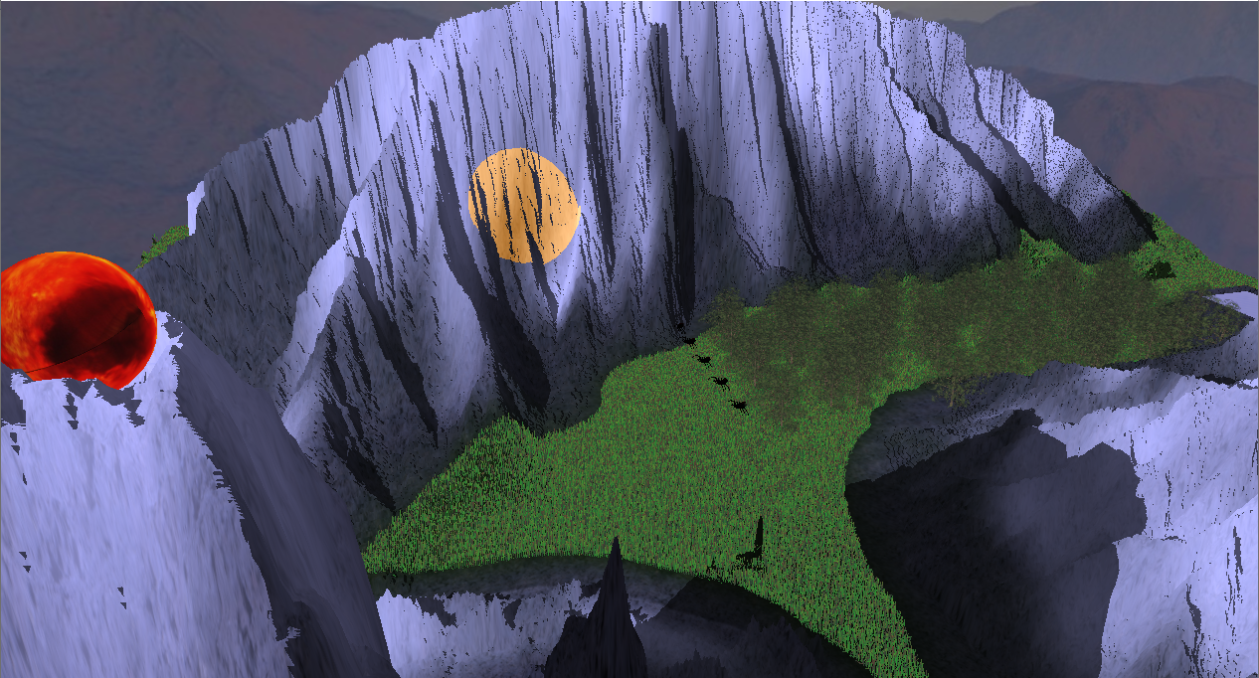

Spotlight “Sauron’s Eye” moving across mountain range. Real-time Shadow Mapping and multiple blended textures also present

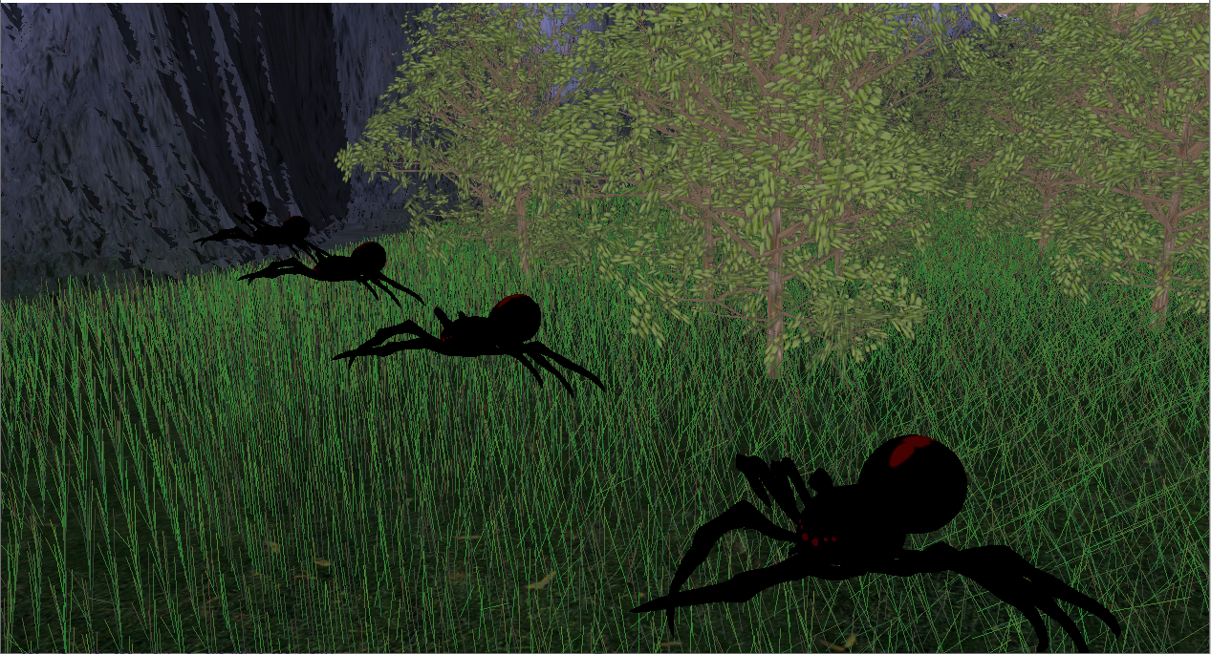

Spider and tree meshes with the spiders showcasing skeletal animation.

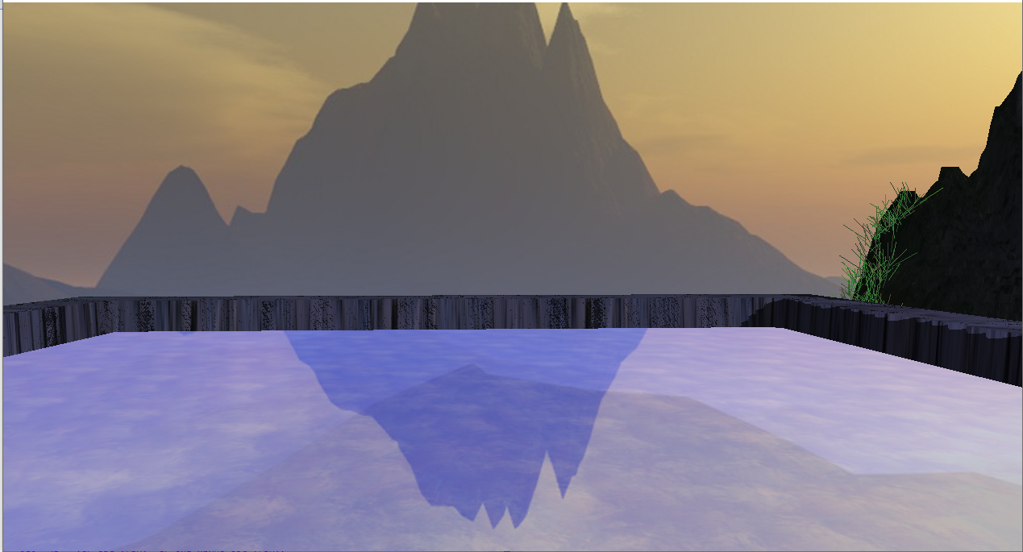

Reflection of cube map in pool of water

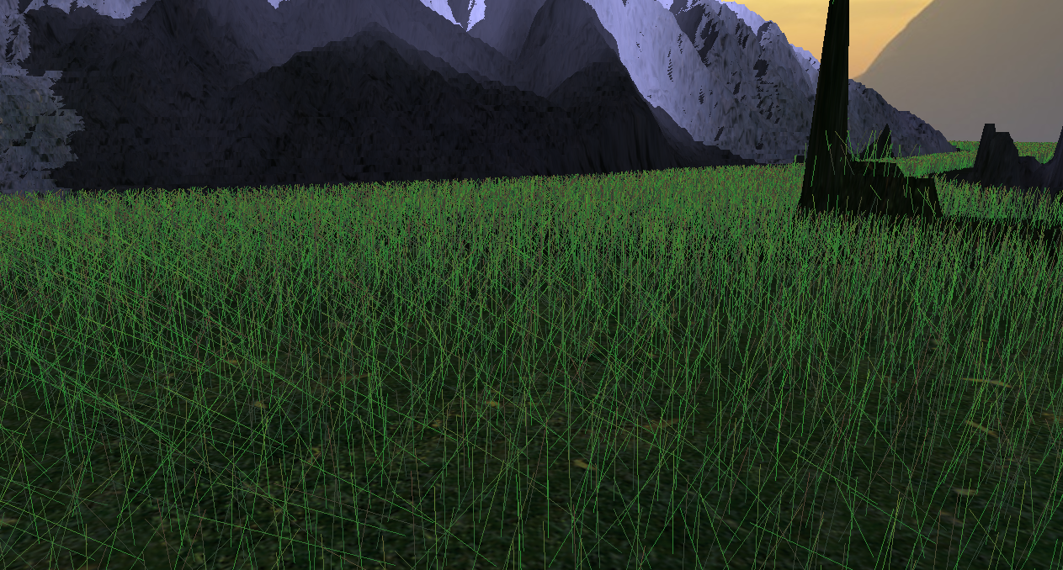

Moving grass, drawn primitives in geometry shader